**Pertemuan 10**

**Workshop Web Design**



|  |  |  |
| --- | --- | --- |
| Nama | : | Defri Indra Mahardika |
| NRP | : | 3120510402 |
| PRODI | : | D3 PJJ TI B |

1. Percobaan 1

<!DOCTYPE html>

<html>

<head>

    <script src="https://ajax.googleapis.com/ajax/libs/jquery/3.5.1/jquery.min.js"></script>

    <script>

        $(document).ready(*function* () {

            $("button").click(*function* () {

                $("p").hide();

            });

        });

    </script>

</head>

<body style="background-color : #FFF;">

    <h2>This is a heading</h2>

    <p>This is a paragraph.</p>

    <p>This is another paragraph.</p>

    <button>Click me to hide paragraphs</button>

</body>

</html>

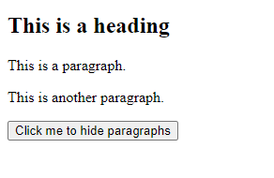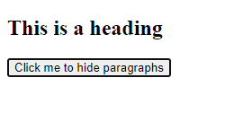

Script di atas digunakan untuk men-disable semua tag paragraph

1. Percobaan 2

<!DOCTYPE html>

<html>

<head>

    <script src="https://ajax.googleapis.com/ajax/libs/jquery/3.5.1/jquery.min.js"></script>

    <script>

        $(document).ready(*function* () {

            $("button").click(*function* () {

                $("#test").hide();

            });

        });

    </script>

</head>

<body style="background-color: #FFF;">

    <h2>This is a heading</h2>

    <p>This is a paragraph.</p>

    <p id="test">This is another paragraph.</p>

    <button>Click me</button>

</body>

</html>

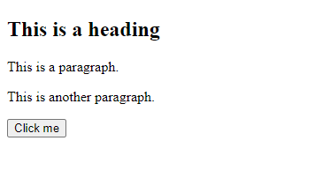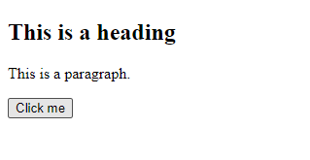

Script diatas digunakan untuk menyembunyikan element ber-id tertentu

1. Percobaan 3

<!DOCTYPE html>

<html>

<head>

    <script src="https://ajax.googleapis.com/ajax/libs/jquery/3.5.1/jquery.min.js"></script>

    <script>

        $(document).ready(*function* () {

            $("button").click(*function* () {

                $(".test").hide();

            });

        });

    </script>

</head>

<body style="background-color: #FFF;">

    <h2 class="test">This is a heading</h2>

    <p class="test">This is a paragraph.</p>

    <p>This is another paragraph.</p>

    <button>Click me</button>

</body>

</html>

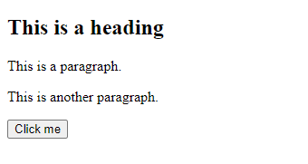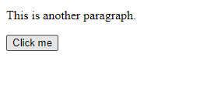

Script diatas digunakan untuk menyembunyikan element ber-id tertentu

1. Percobaan 4

<!DOCTYPE html>

<html>

<head>

    <script src="https://ajax.googleapis.com/ajax/libs/jquery/3.5.1/jquery.min.js"></script>

    <script>

        $(document).ready(*function* () {

            $("p").click(*function* () {

                $(this).hide();

            });

        });

    </script>

</head>

<body style="background-color: #FFF;">

    <p>If you click on me, I will disappear.</p>

    <p>Click me away!</p>

    <p>Click me too!</p>

</body>

</html>

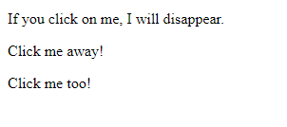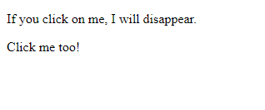

Jika salah 1 paragraf diatas di klik maka akan hilang

1. Percobaan 5

<!DOCTYPE html>

<html>

<head>

    <script src="https://ajax.googleapis.com/ajax/libs/jquery/3.5.1/jquery.min.js"></script>

    <script>

        $(document).ready(*function* () {

            $("p").dblclick(*function* () {

                $(this).hide();

            });

        });

    </script>

</head>

<body style="background-color: #FFF;">

    <p>If you double-click on me, I will disappear.</p>

    <p>Click me away!</p>

    <p>Click me too!</p>

</body>

</html>

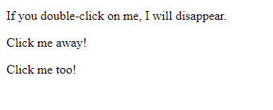

Jika salah 1 paragraf diatas di double klik maka akan hilang

1. Percobaan 6

<!DOCTYPE html>

<html>

<head>

    <script src="https://ajax.googleapis.com/ajax/libs/jquery/3.5.1/jquery.min.js"></script>

    <script>

        $(document).ready(*function* () {

            $("#p1").mouseleave(*function* () {

                alert("Bye! You now leave paragraph 1!");

            });

        });

    </script>

</head>

<body style="background-color: #FFF;">

    <p id="p1">This is a paragraph.</p>

</body>

</html>

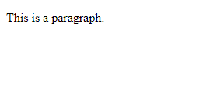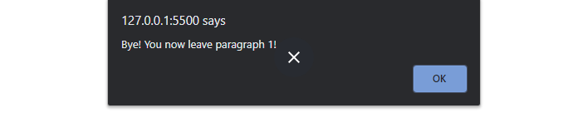

Jika cursor diarahkan ke paragraph kemudian dipindahkan maka akan mucul alert seperti diatas.

1. Percobaan 7

<!DOCTYPE html>

<html>

<head>

<script src="https://ajax.googleapis.com/ajax/libs/jquery/3.5.1/jquery.min.js"></script>

<script>

$(document).ready(*function*(){

  $("#hide").click(*function*(){

    $("p").hide();

  });

  $("#show").click(*function*(){

    $("p").show();

  });

});

</script>

</head>

<body style="background-color: #FFF;">

<p>If you click on the "Hide" button, I will disappear.</p>

<button id="hide">Hide</button>

<button id="show">Show</button>

</body>

</html>

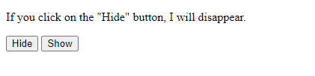

Klik button untuk men-trigger action

1. Percobaan 8

<!DOCTYPE html>

<html>

<head>

<script src="https://ajax.googleapis.com/ajax/libs/jquery/3.5.1/jquery.min.js"></script>

<script>

$(document).ready(*function*(){

  $("button").click(*function*(){

    $("p").hide(1000);

  });

});

</script>

</head>

<body style="background-color: #FFF;">

<button>Hide</button>

<p>This is a paragraph with little content.</p>

<p>This is another small paragraph.</p>

</body>

</html>

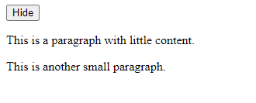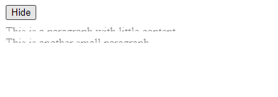

Jika button hide diklik maka paragraph akan terhide dalam waktu 1 detik

1. Percobaan 9

<!DOCTYPE html>

<html>

<head>

<script src="https://ajax.googleapis.com/ajax/libs/jquery/3.5.1/jquery.min.js"></script>

<script>

$(document).ready(*function*(){

  $("button").click(*function*(){

    $("#div1").fadeIn();

    $("#div2").fadeIn("slow");

    $("#div3").fadeIn(3000);

  });

});

</script>

</head>

<body style="background-color: #FFF;">

<p>Demonstrate fadeIn() with different parameters.</p>

<button>Click to fade in boxes</button><br><br>

<div id="div1" style="width:80px;height:80px;display:none;background-color:#169670;"></div><br>

<div id="div2" style="width:80px;height:80px;display:none;background-color:#bb35b0;"></div><br>

<div id="div3" style="width:80px;height:80px;display:none;background-color:#c96111"></div>

</body>

</html>

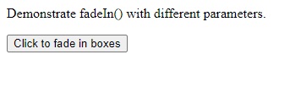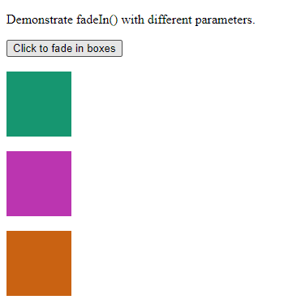

Fade in dengan effect

1. Percobaan 10

<!DOCTYPE html>

<html>

<head>

<script src="https://ajax.googleapis.com/ajax/libs/jquery/3.5.1/jquery.min.js"></script>

<script>

$(document).ready(*function*(){

  $("#flip").click(*function*(){

    $("#panel").slideDown("slow");

  });

});

</script>

<style>

#panel, #flip {

*padding*: 5px;

*text-align*: center;

*background-color*:#d0fdd0;

*border*: solid 1px #518813;

}

#panel {

*padding*: 50px;

*display*: none;

}

</style>

</head>

<body style="background-color: #FFF;">

    <div id="flip">Click to slide down panel</div>

    <div id="panel">Hello world!</div>

    </body>

    </html>



Membuat slide down animation pada panel